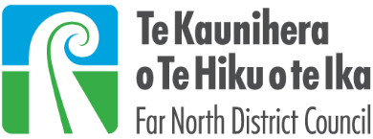
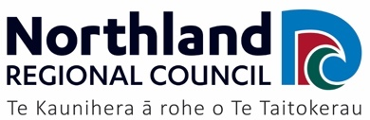
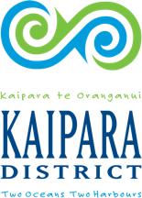
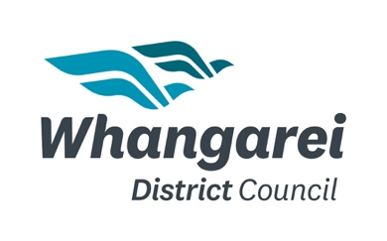
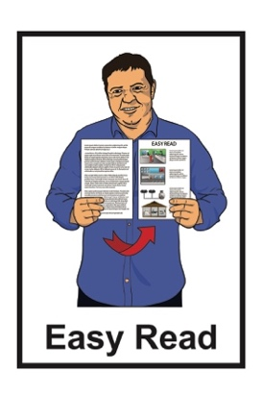

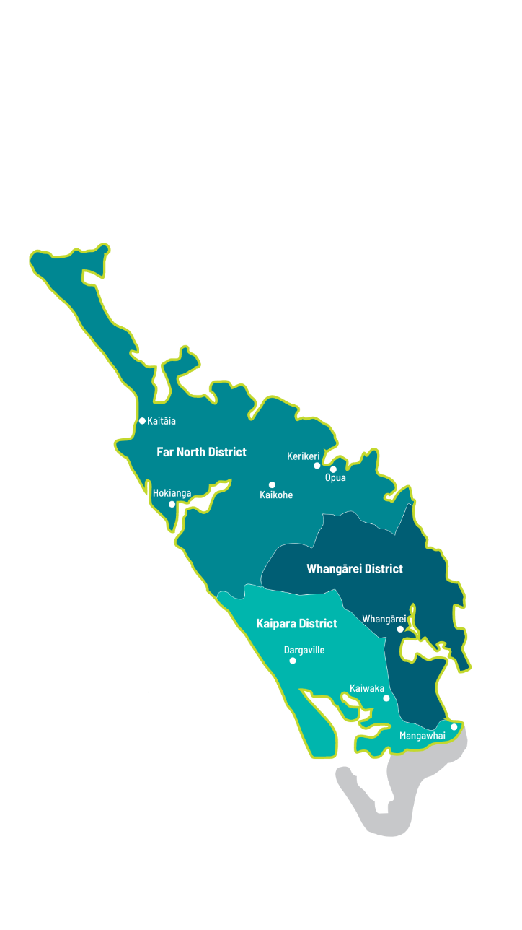
Summary: Te Tai Tokerau
Accessibility Strategy
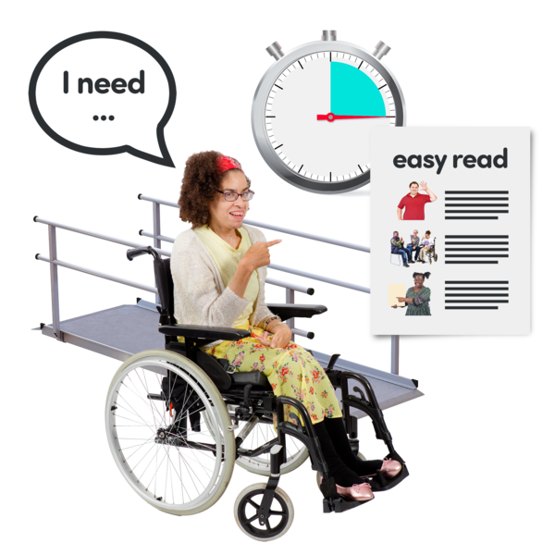

Published: May 2024

Before you start

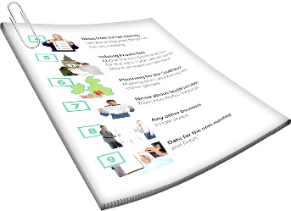
This is a long document.

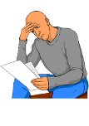
It can be hard for some people to read a document this long.

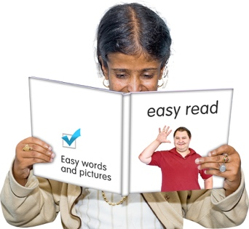
Some things you can do to make it easier are:
read it a few pages at a time
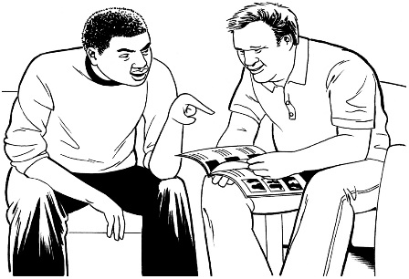
set aside some quiet time to look at it
have someone read it with you to support you to understand it.

What you will find in here

Page number:


What is in this document 4

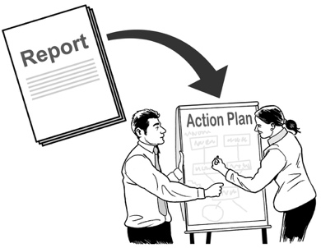
How we made the strategy 9

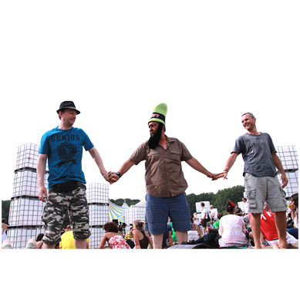
What the strategy says 14

Goal 1 – everyone can join in 24
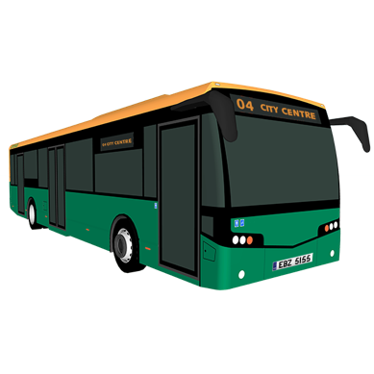

Goal 2 – everyone can get where
they want to go 29
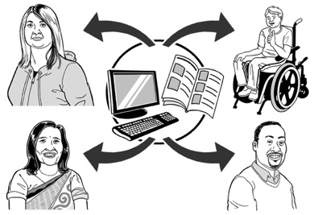

Goal 3 – it is easy to communicate
with the councils 34
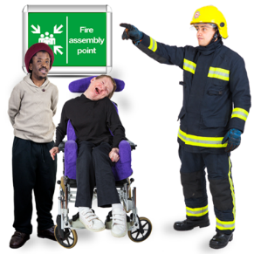
Page number:

Goal 4 – everyone can feel safe 39
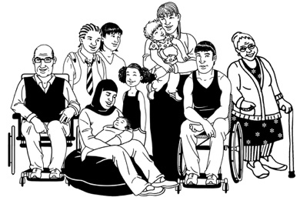

Goal 5 – everyone is included 43

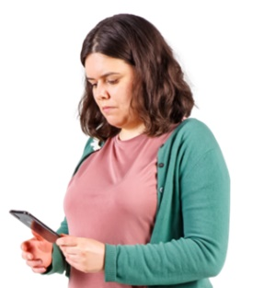
More information 46

What is in this document
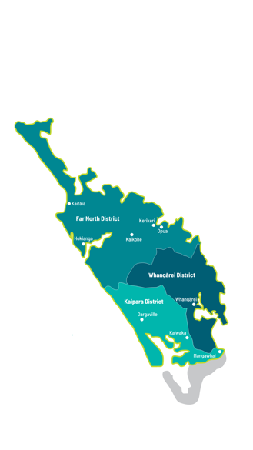

This Easy Read information is from the councils of Te Tai Tokerau / Northland.

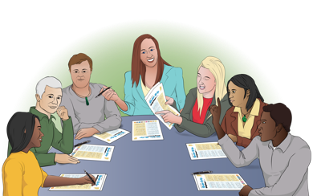
Council means the people who are in charge of how things work in a:
town
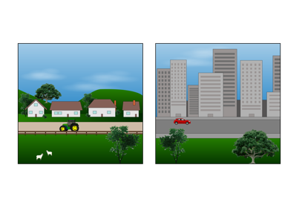
city
district / region.

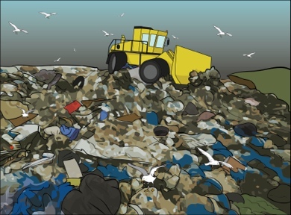
Councils run things like:
rubbish collection
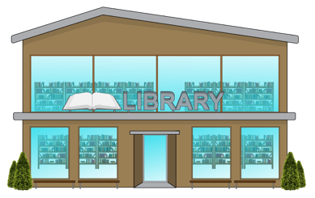
parks
libraries.

The councils for Te Tai Tokerau are:
Northland Regional Council
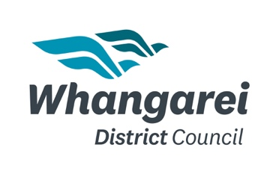
Far North District Council
Whangarei District Council
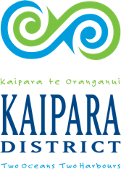
Kaipara District Council.

When you see we / our in this document it means the councils of
Te Tai Tokerau.

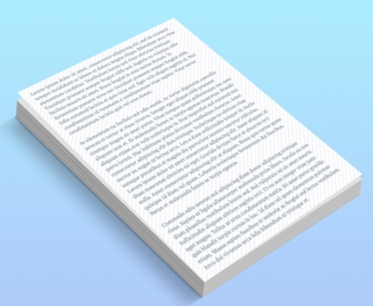
This document is a summary of a longer document.

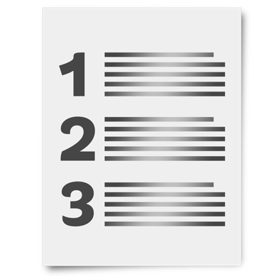
A summary:
is shorter than the full document
tells you the main ideas.


You can read the full document at:

www.nrc.govt.nz/accessiblenorthland
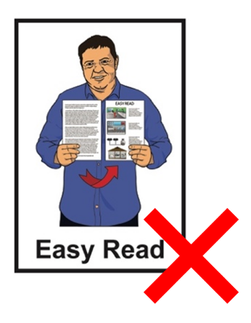

The full document is not in Easy Read.

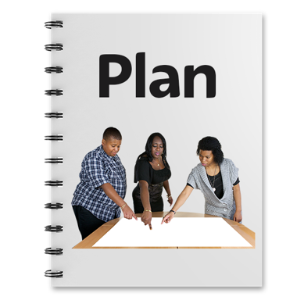
This document is about our strategy to make Te Tai Tokerau more:
inclusive
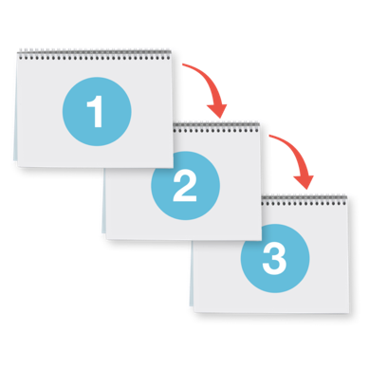
accessible.

A strategy is a plan for how to make things happen.

Inclusive means everyone can take part.

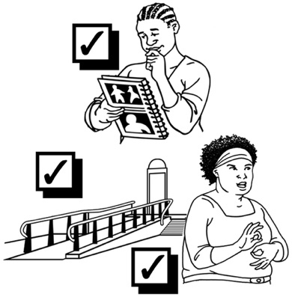
Accessible means everyone can:
do the things they want to do
get to the places they want to go.

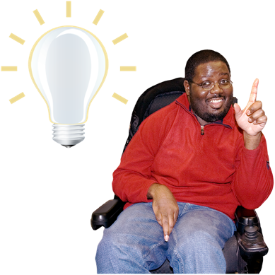
The strategy says what we:
think is important
want to change
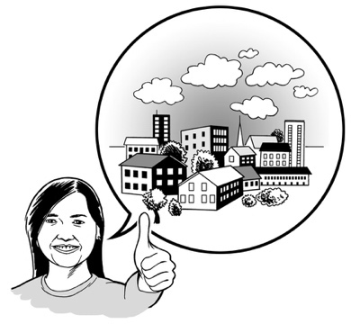
will do.

Each council can do things that work for their community.

How we made the strategy

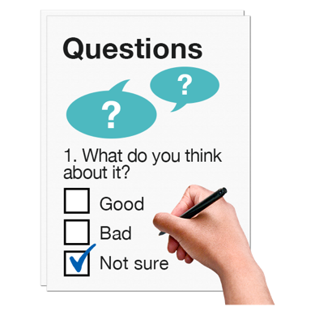
We did a survey to find out if people thought Te Tai Tokerau was accessible.

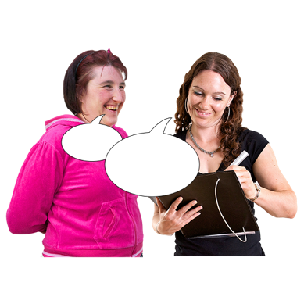
A survey is a way to do research by asking a lot of people to answer questions.


Research is when someone:
looks at what is happening



tries to find ways to do things differently.

Only a few people thought Te Tai Tokerau was accessible.

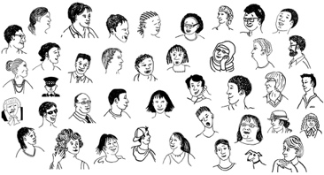

Most people thought Te Tai Tokerau was not very accessible.

This told us that we needed to make an accessibility strategy.

We asked a lot of people with access needs what:
would make their community more accessible
should be in our strategy.
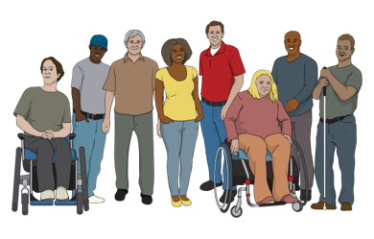

People with access needs include:
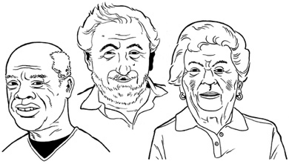
disabled people
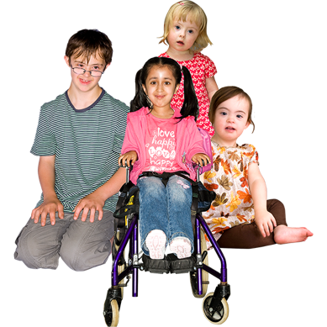
people with health problems
old people
children.
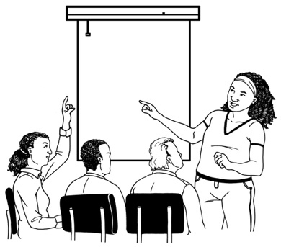
We asked people about accessibility in different ways like:
workshops
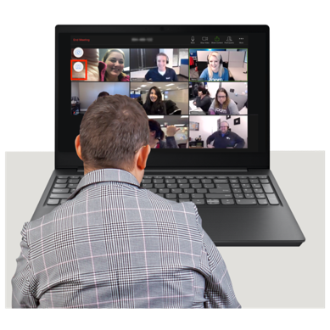
surveys
online meetings.

Some other groups we talked with were:
the Positive Ageing Advisory Group from the Whangarei District Council
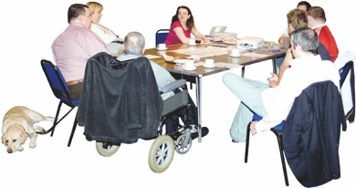
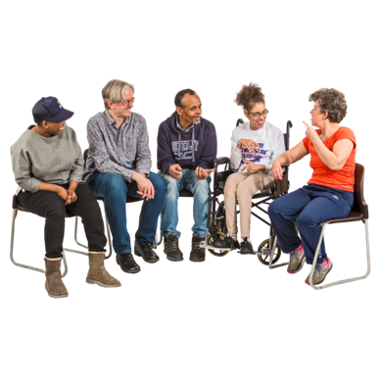
the Disability Advisory Group from the Whangarei District Council
the Disability Action Group from the Far North District Council.

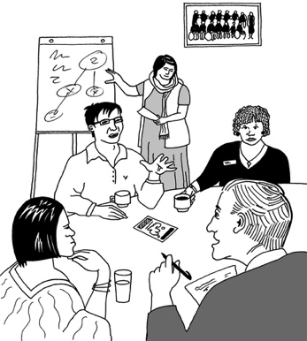
We put together a group of people to work on the strategy.

The group included:
council staff
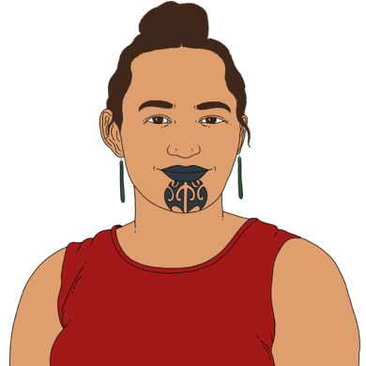
people with access needs
whānau hauā / Māori disabled people
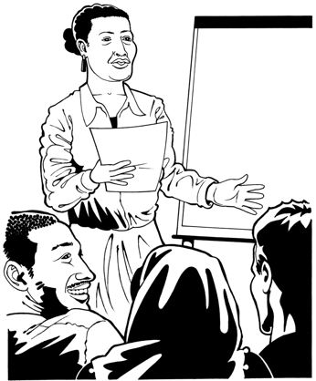
a kaiārahi tikanga Māori / Māori cultural advisor
a facilitator.

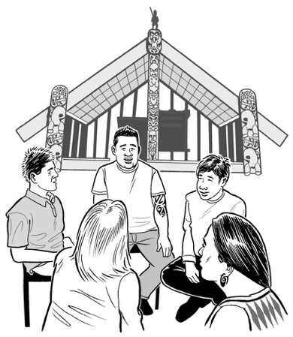
A kaiārahi tikanga Māori / Māori cultural advisor supports people to:
understand Māori culture
do things in a way that works for Māori.
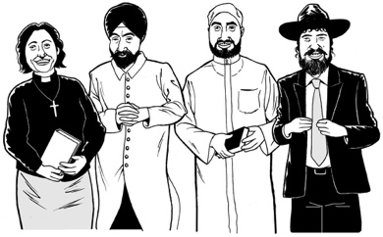
Culture means:
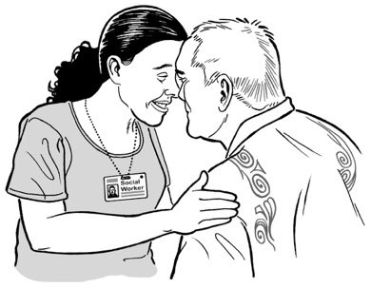
the things a group of people believe
the way a group of people do things.

Facilitator means someone whose job is to make sure:
everything runs smoothly
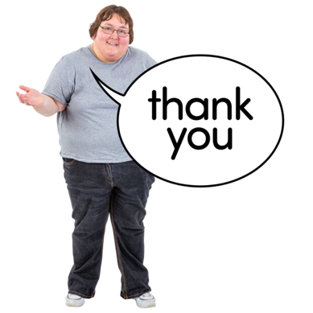
everyone knows what they need to do.

We want to say thank you to this group for all their hard work.

What the strategy says

The strategy talks about our vision for Te Tai Tokerau.

Vision means:
the things we want to happen in the future

what we will do to make these things happen.

Future means in the time / years to come.

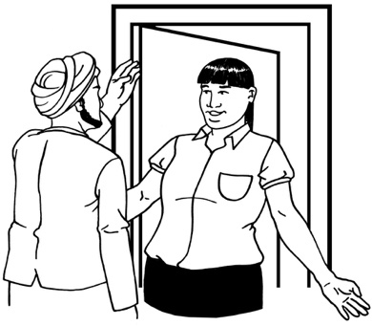
He Ara Whaikaha o Te Tai Tokerau / A Journey of Strength for Northland

He wāhi maioha / This is a place of welcome


He wāhi taurikura / A place that is positive and thriving

He tūāpapa mō ngā tangata whaikaha katoa / A foundation for all people with access needs.

There are 5 goals in our strategy.

A goal is something we want to do in the future / years ahead.

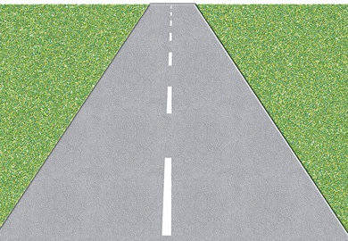
The strategy looks at:
transport like:
- roads
- footpaths
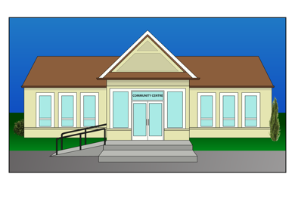
- buses
the buildings owned by the council
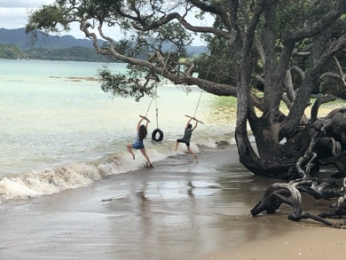
public places like:
- beaches
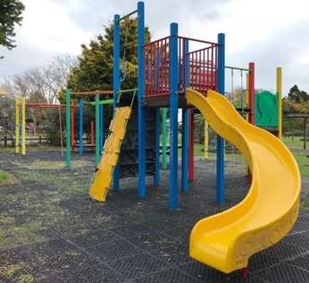
- parks
- playgrounds
events like:
- concerts
- festivals.

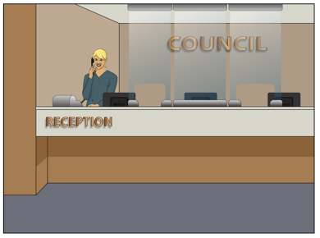
The strategy also looks at how people communicate with the council.

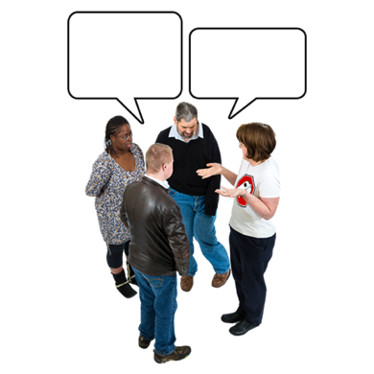
Communicate means all the ways we share information like:
talking
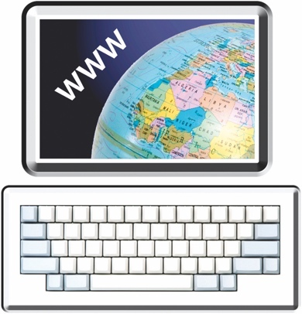
writing
websites
newletters.

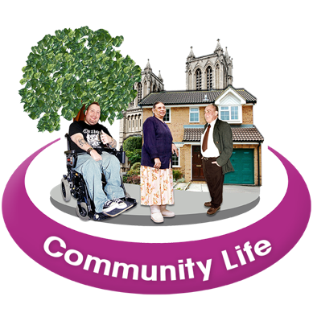
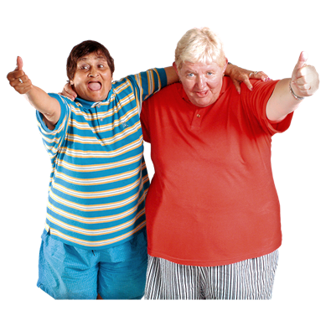
We want to make sure that people with access needs get to join in with everything that happens in their community.

We want people with access needs to feel safe.
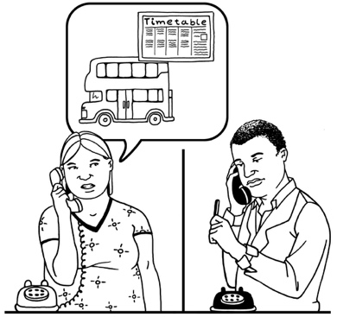
We want to make sure everyone can:
get the information they need
get to where they need to go.

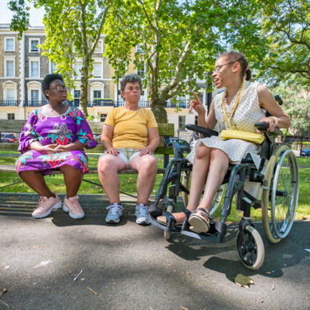
We will know the strategy is working when:
everyone can easily go to:
- public places
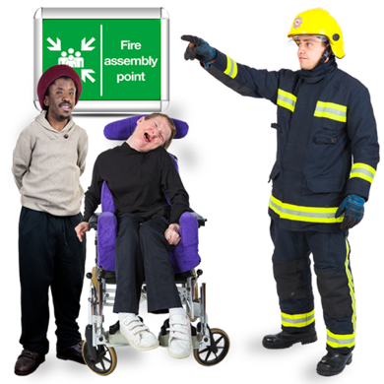
- events
we can keep people with access needs safe in an emergency
everyone can communicate with their council.

We will know the strategy is working when:
there is transport that works for everyone
disabled people are part of all the choices we make.

There are some important values that we will use in our work.

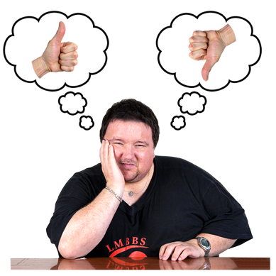
Values are the things we think are important.

Our values tell us how to behave.

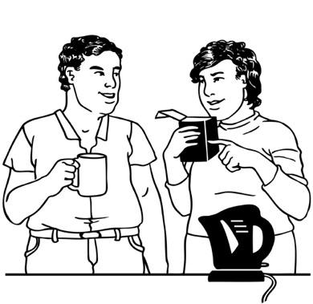
The values we will use are:
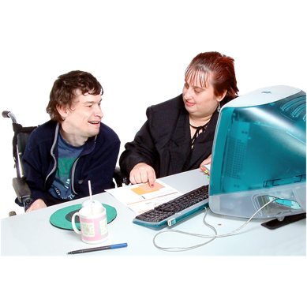
manaakitanga – caring about people
mahi tahi – working together
whanaungatanga – being part of the community
āhurutanga – making sure everyone feels safe to be themself.

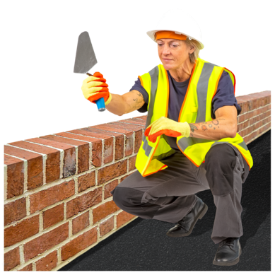
We will use universal design when we build new things.

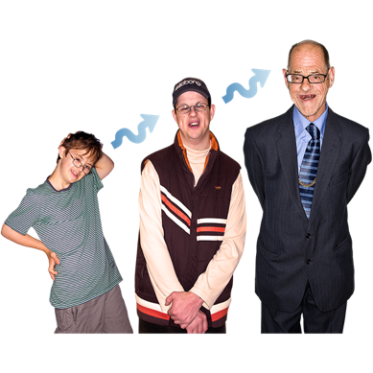
Universal design means making things that can be used by everyone no matter:
how old they are
what size they are
what disabilities they have.

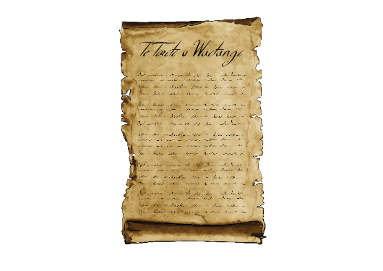
We will remember that Te Tiriti o Waitangi is important.

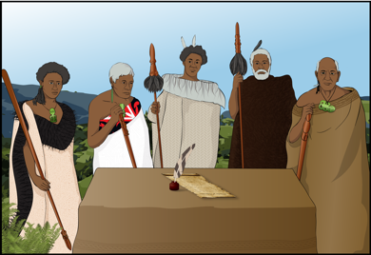
Te Tiriti o Waitangi / The Treaty of Waitangi is an agreement between Māori and the British Crown.

Te Tiriti is important to New Zealand.

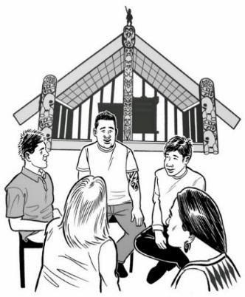
It is about Māori and the New Zealand Government:
- making decisions together
protecting things that are Māori.

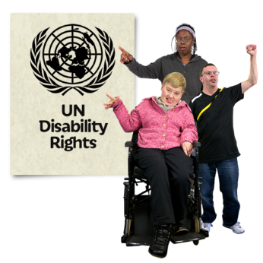
We will follow the United Nations Convention on the Rights of Persons with Disabilities.

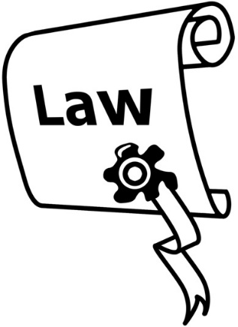
The United Nations Convention on the Rights of Persons with Disabilities is a law lots of countries have agreed to.

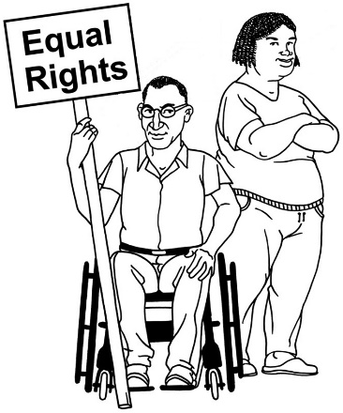
The United Nations Convention on the Rights of Persons with Disabilities is also called the UNCRPD.

It says what governments must do to make sure disabled people get the same rights as everybody else.

Goal 1 – everyone can join in

Goal 1 is about people with access needs being able to join in with their:
community
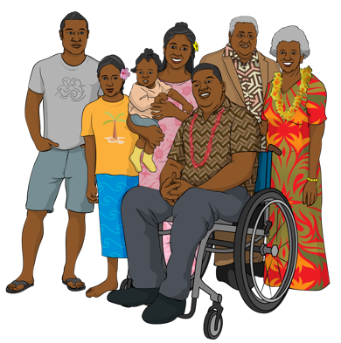
whānau / family
iwi
friends.

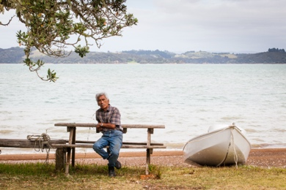
We want to make sure everyone can:
go to some beaches
be safe when they go to the beach.

We want to make a lot of accessible places like:
parks
playgounds
recreation facilities.

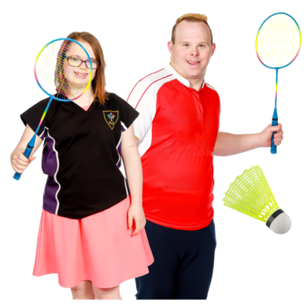
Recreation means things people do for fun like:
swimming
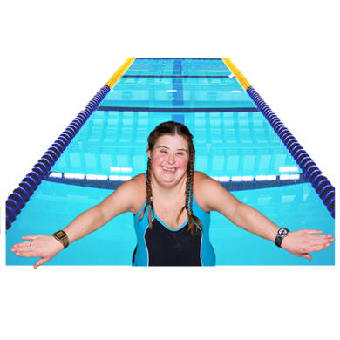
playing sport.

Recreation facilities are places for recreation like:
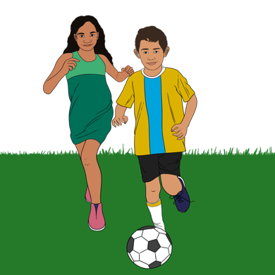
swimming pools
sports fields
gyms.
We want to make all the events the council runs accessible for everyone.

We also want to make sure that all our council buildings are accessible.

The things we are going to do to meet Goal 1

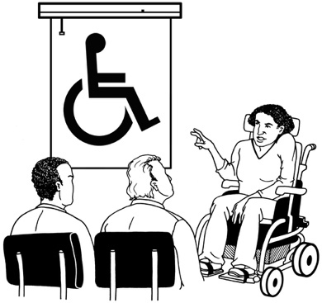
We are going to teach council staff about accessibility.

We are going to use universal design every time we build new:
buildings
parks
playgrounds.

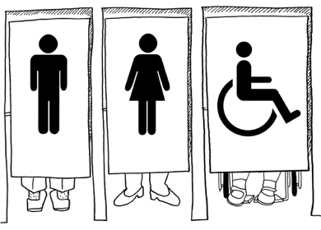
We are going to:
build more accessible toilets
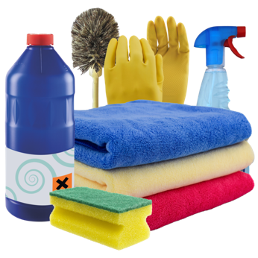
make sure the accessible toilets are kept clean.

We will find ways to make some of our beaches accessible.

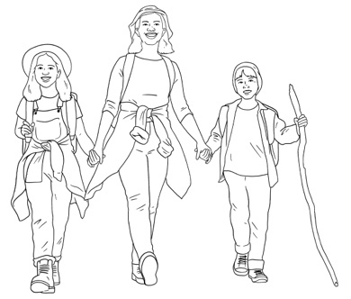
We will make more accessible walking tracks.

We are going to think about how we plan events to make them accessible for more people.
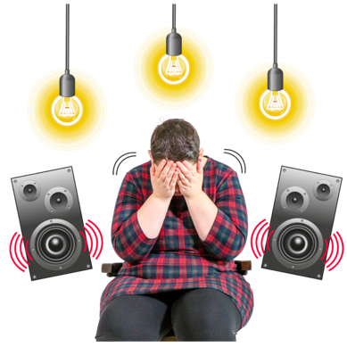

1 way we might change how we plan events is to have quiet times for people with sensory needs.
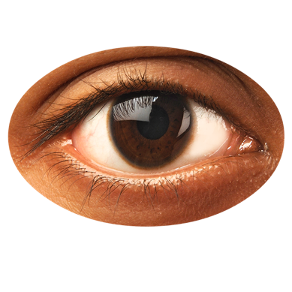

Sensory means something is about your senses like:
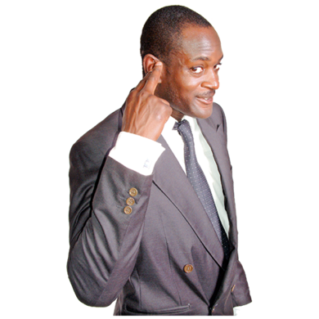
seeing
hearing.

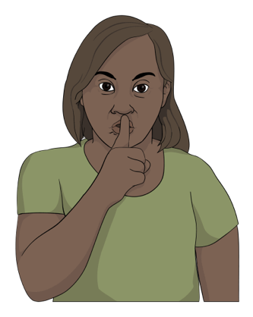
People with sensory needs might need things like:
quiet spaces
soft lighting.

Goal 2 – everyone can get where they want to go

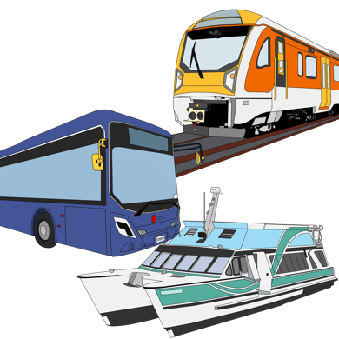
Goal 2 is about transport.

We will be looking at public transport like:
buses
ferries.
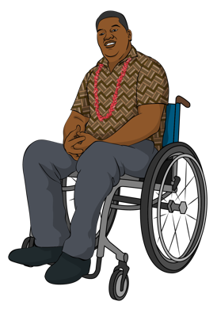

We plan to make public transport that works for people with access needs like:
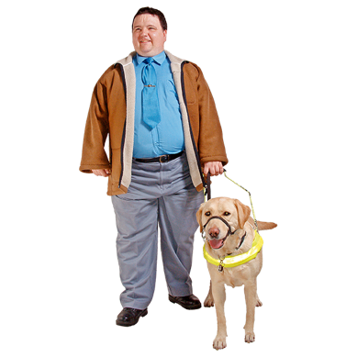
using a wheelchair
being blind / low vision
having small children.
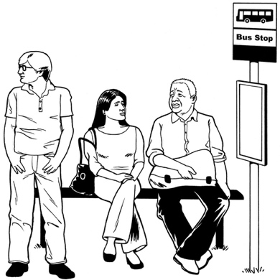
We want to make sure public transport runs at the times people need it.

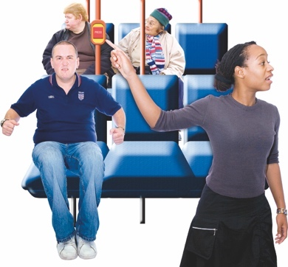
We want everyone to be safe when they use public transport.

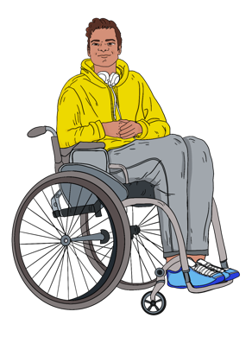
We will also make it easier for people to get around by things like:
walking
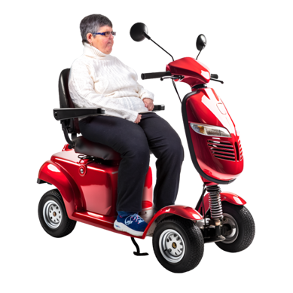
using a wheelchair
using a mobility scooter.

We will make paths that:
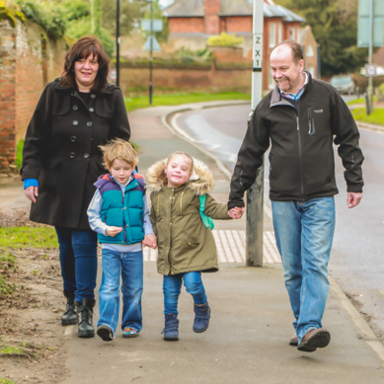
are easy to find
are safe to use
do not have steps.

The things we are going to do to meet Goal 2

We will speak up to get different sorts of public transport to work well together.

We will make sure that new public transport is accessible.

We will teach people about shared paths.

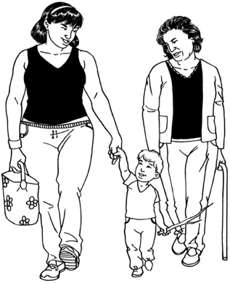
Shared paths are paths that can be used by people who are:
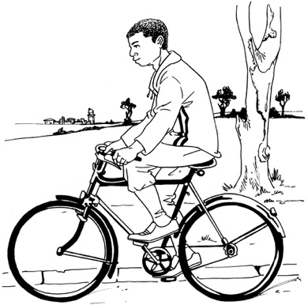
walking
riding a bike
using a wheelchair.
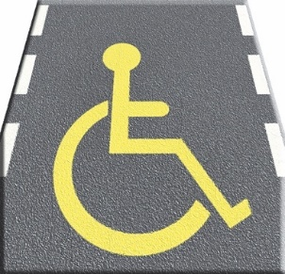
We will also teach people about mobility parking.

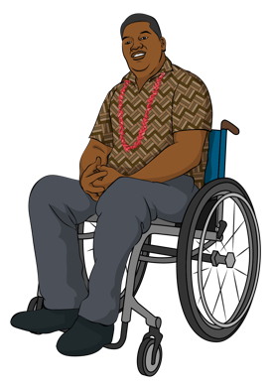
Mobility parking means places to park your car that are just for people who:
use a wheelchair / mobility aid
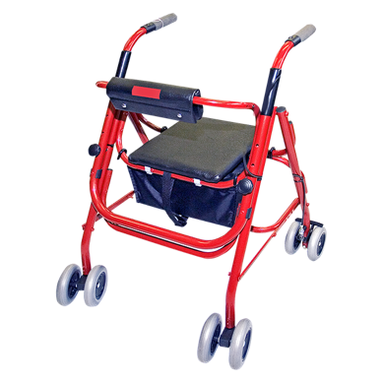
find it hard to walk very far.

You have to have a permit to use mobility parking.
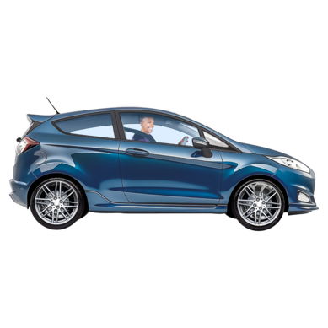

We will make sure there are enough carparks where people need them.
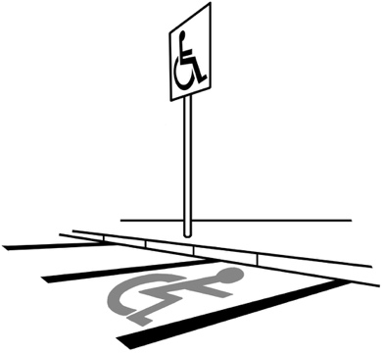

We will take extra care to make sure there is enough mobility parking.

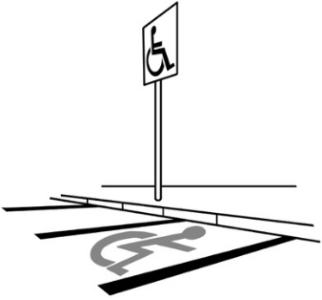
We will make sure everyone follows the rules about mobility parking.

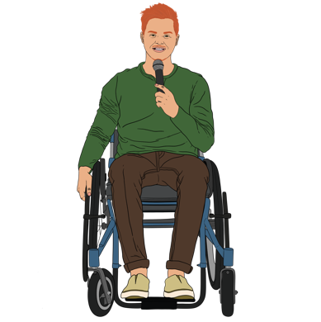
We will speak up to give people with access needs a say when we are making plans for transport.

We will check our footpaths to see if they are okay for people with access needs.


We will speak up to the Government to get money to:
make our footpaths better
build more footpaths.
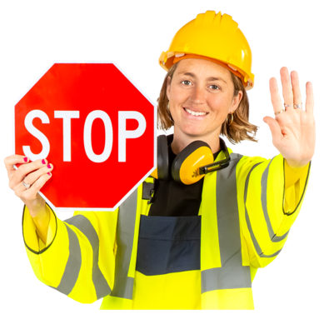

We will make sure footpaths stay accessible when there are things like roadworks.

Goal 3 – it is easy to communicate with the councils

Goal 3 is about how people can:
get in touch with their council
get information from their council
use council services like:
- rubbish dumps
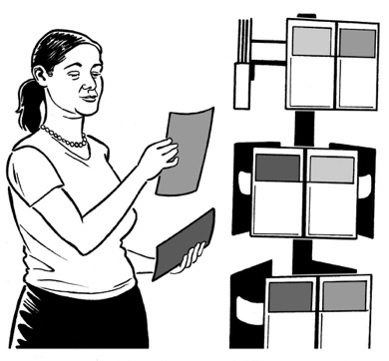
- libraries.

We want to make sure that we have information that everyone can:
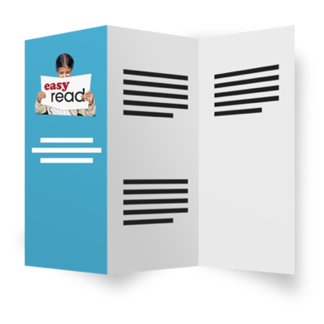
use
understand.

We want to make it easy for people to get in touch with their council.

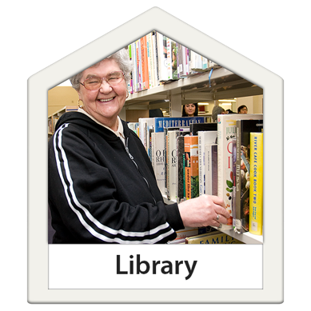
We want to make sure everyone can use our services.

We plan to use lots of different ways for people to:
get information from the council
tell the council things.

The things we are going to do to meet Goal 3

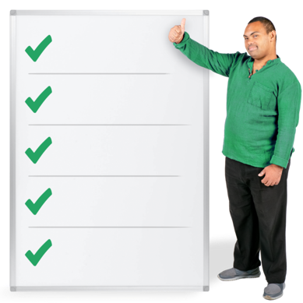
We are going to write some guidelines about accessible communication.

Guidelines say what the right way to do something is.

We will work to understand what sort of communication different people need.
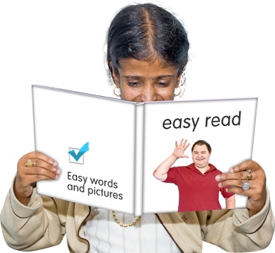

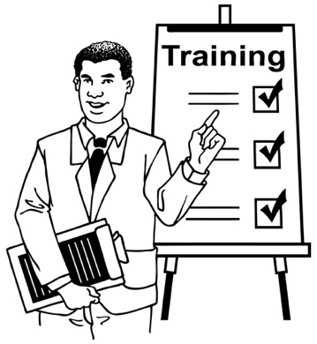
We will make sure that there is information that people can use for themselves.

We will teach our staff about accessibility.
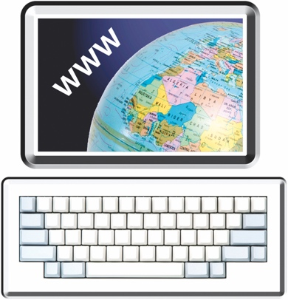
We will look at how accessible our website is.

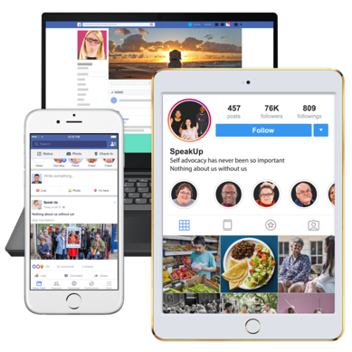
We will also look at how we use social media like:
Facebook
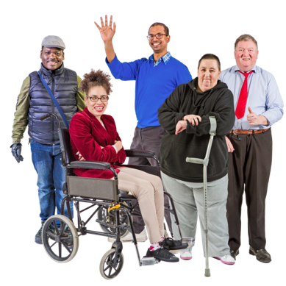
Instagram.

We will use pictures in our information that show:
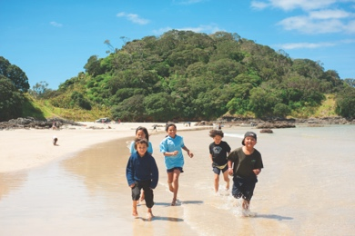
real people with access needs
people in Te Tai Tokerau.
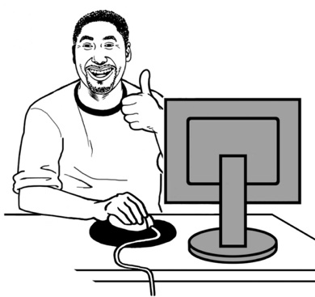

We will make it easy to find out about accessible services.

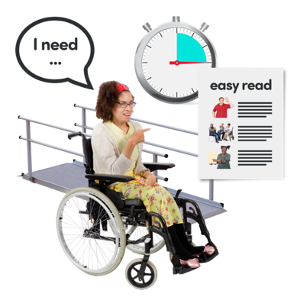
When someone asks us about accessibility we will make sure they get an answer that is:
fast
useful.

Goal 4 – everyone can feel safe

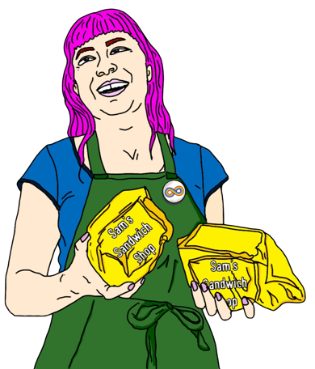
Goal 4 is about making sure everyone is safe when:
they go about their lives
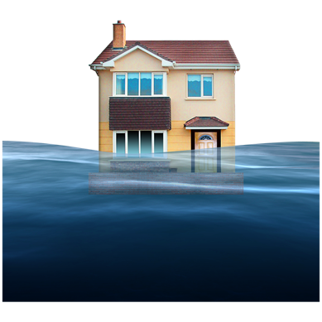
there is an emergency like a:
- fire
- cyclone
- flood.

We will make sure our emergency plans put people with access needs first.

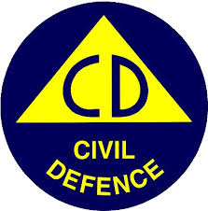
We will make sure Civil Defence facilities are accessible.

Civil Defence facilities are places you can go when you cannot be in your house because of an emergency.

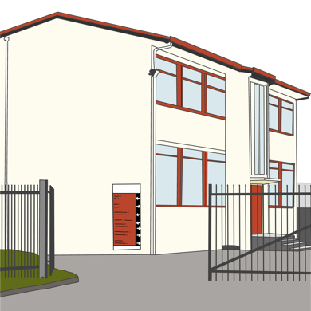
Civil defence facilities might be in places like:
schools
marae.
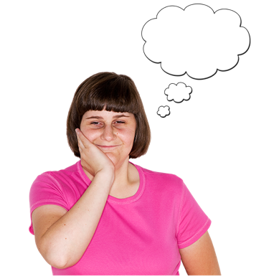

We will think about safety in everything we do.

The things we are going to do to meet Goal 4

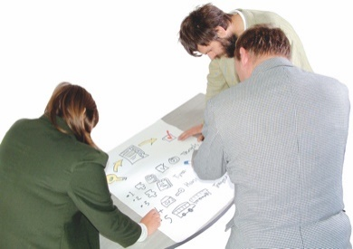
We will work with people with access needs when we plan for emergencies.

We will speak up to Civil Defence about how to support people with access needs.

Civil Defence is in charge of:
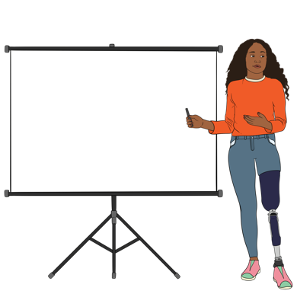
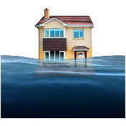
teaching people what to do in an emergency
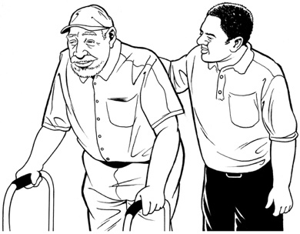
supporting councils to plan for emergencies
assisting people when there is an emergency.

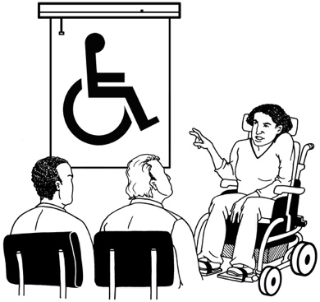
We will give training about people with access needs to groups like:
Māori Wardens
community patrols.
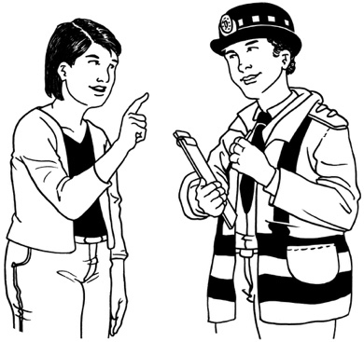

Māori Wardens work with the police to keep people safe.

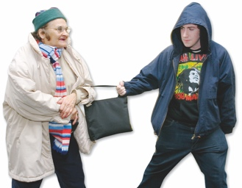

Community patrols look out to stop crime in their community.

Goal 5 – everyone is included

Goal 5 is about making sure everyone can take part in all the things the council does.

We think that the experiences of disabled people are important.


We will think about the things disabled people tell us when we make:
plans
choices.
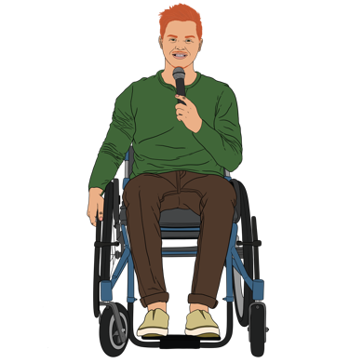

People with access needs should have a say in everything their council does.
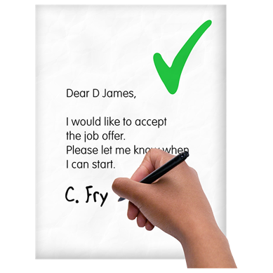
We want to fix anything that makes it harder for people with access needs to get a job with the council.

The things we are going to do to meet Goal 5

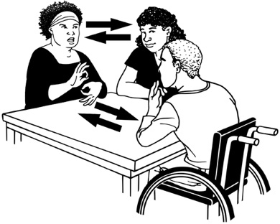
We will support people with access needs to apply for council jobs.

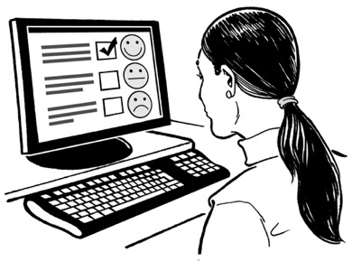
We will find ways to make it easier for people to tell us:
if we are doing a good job
what we should change.

We will make sure that we have public meetings in accessible places.

Public meetings are meetings that everyone can go to.
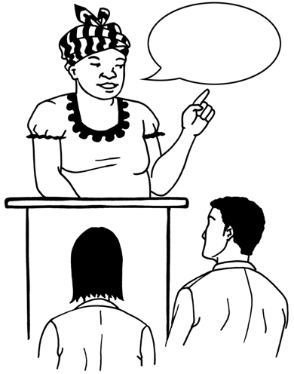

Public meetings might be to:
give people information
find out what people think.

More information

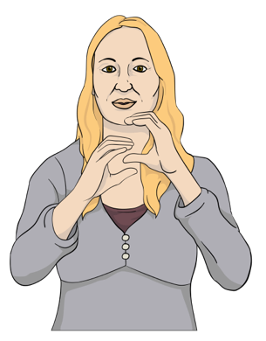
The Te Tai Tokerau Accessibility Strategy document is also in:
New Zealand Sign Language
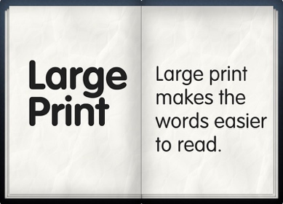
large print
audio
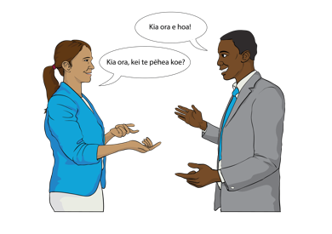
Braille
te reo Māori.


You can get in touch with the councils who wrote this information.

Northland Regional Council

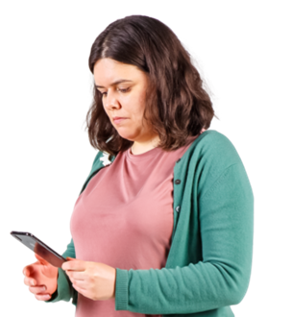
Phone: 0800 002 004

Email: info@nrc.govt.nz

Post: Private Bag 9021
Te Mai
Whangārei 0143

Far North District Council

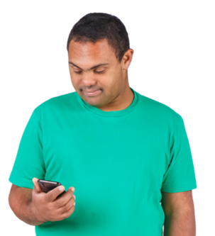
Phone: 0800 920 029

Email: email@fndc.govt.nz

Post: Private Bag 752
Kaikohe 0440

Kaipara District Council

Phone: 0800 727 059
Email: council@kaipara.govt.nz

Post: Private Bag 1001
Dargaville 0340

Whangarei District Council

Phone: 0800 932 463

Email: mailroom@wdc.govt.nz

Post: Private Bag 9023
Te Mai
Whangārei 0143

You can use the New Zealand Relay service to phone any of the councils.


If you find it hard to use the phone the New Zealand Relay service is for people who are:

- Deaf / hard of hearing

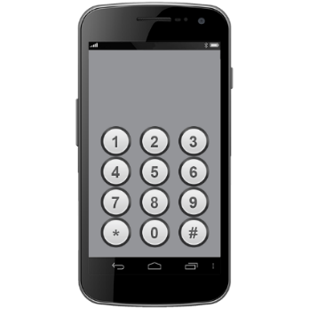
- deafblind

- speech impaired / find it hard to talk.

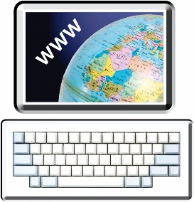
You can find out more about the New Zealand Relay service at:

www.nzrelay.co.nz

This information has been written by the councils of Te Tai Tokerau Northland.

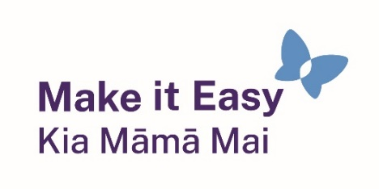
It has been translated into Easy Read by the Make it Easy Kia Māmā Mai service of People First New Zealand Ngā Tāngata Tuatahi.

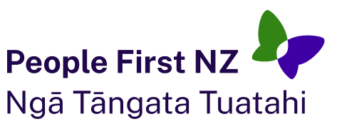
The ideas in this document are not the ideas of People First New Zealand Ngā Tāngata Tuatahi.
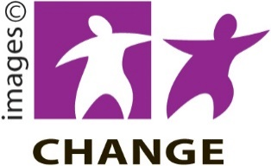
Make it Easy uses images from:
- Changepeople.org


            - Photosymbols.com

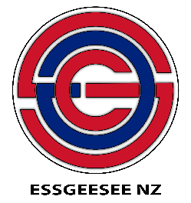
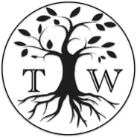
- SGC Image Works
- Huriana Kopeke-Te Aho
- T. Wood.

All images used in this Easy Read document are subject to copyright rules and cannot be used without permission.

